Experiment No. 13
You are tasked with developing an Online Learning Platform. The platform should include the following functionalities:

Course Enrollment and Registration

Video Lecture Streaming

Interactive Quizzes and Assignments

Progress Tracking Dashboard

Peer-to-Peer Discussion Forums

Certificate Generation
Use Jira to categorize and prioritize these requirements using MoSCoW and Kano techniques
Aim
To categorize and prioritize the functional requirements of an Online Learning Platform using the MoSCoW and Kano prioritization techniques, implemented through Jira software.
Software Required
Jira (Cloud version — jira.atlassian.com / your organization's Jira instance)
Requirements to be Prioritized
- Course Enrollment and Registration
- Video Lecture Streaming
- Interactive Quizzes and Assignments
- Progress Tracking Dashboard
- Peer-to-Peer Discussion Forums
- Certificate Generation

Part A: Theory
MoSCoW Technique
MoSCoW classifies requirements into four categories:
- Must Have — critical, non-negotiable for launch
- Should Have — important but not vital; can be delayed if needed
- Could Have — desirable but not necessary; nice-to-have
- Won't Have (this time) — out of scope for the current release
Kano Model
Kano classifies requirements based on customer satisfaction impact:
- Basic (Must-be) — expected by users; absence causes dissatisfaction
- Performance — satisfaction increases proportionally with how well it's implemented
- Excitement (Attractive) — unexpected features that delight users
- Indifferent — features users don't care about either way

Part B: Procedure in Jira
Step 1: Create a Jira Project
- Log in to Jira at your-domain.atlassian.net.
- Click "Create Project" on the left sidebar.
- Select template: Scrum or Kanban (Scrum is preferred for backlog prioritization).
- Name the project: "Online Learning Platform".
- Set the project key (e.g., OLP) and click Create.
Step 2: Create an Epic
- Go to the Backlog view.
- Click "Create" (top bar) → set Issue Type to Epic.
- Name the epic: "Online Learning Platform - Core Features".
- Click Create.
Step 3: Create Issues for Each Requirement
- In the Backlog, click "Create issue".
- Set Issue Type to Story.
- Enter the Summary field with each requirement, one at a time:
  - Course Enrollment and Registration
  - Video Lecture Streaming
  - Interactive Quizzes and Assignments
  - Progress Tracking Dashboard
  - Peer-to-Peer Discussion Forums
  - Certificate Generation
- Link each Story to the Epic created in Step 2 (use the Epic Link field).
- Click Create after each entry — this results in 6 stories under the epic.
Step 4: Set Up Custom Labels for MoSCoW
- Open each issue (Story) one at a time.
- On the right panel, find the Labels field.
- Click Add label and type one of the following (create new labels if they don't exist):
  - must-have
  - should-have
  - could-have
  - wont-have
- Assign labels based on the analysis below:
Requirement | MoSCoW Category | Justification
Course Enrollment and Registration | Must Have | Core entry point; platform cannot function without it
Video Lecture Streaming | Must Have | Primary content delivery mechanism
Interactive Quizzes and Assignments | Should Have | Important for learning outcomes, not blocking launch
Progress Tracking Dashboard | Should Have | Enhances user experience, not critical to MVP
Peer-to-Peer Discussion Forums | Could Have | Adds engagement but platform works without it
Certificate Generation | Could Have | Valuable add-on, can be released in a later version
Step 5: Set Up Custom Field for Kano Classification
- Go to Project Settings → Fields (Jira Admin access required).
- Click "Add Field" → choose Select List (single choice).
- Name the field: "Kano Category".
- Add options: Basic, Performance, Excitement, Indifferent.
- Attach this field to your project's issue screen.
- Go back to each Story and set its Kano Category value:
Requirement | Kano Category | Justification
Course Enrollment and Registration | Basic | Expected baseline; its absence causes major dissatisfaction
Video Lecture Streaming | Basic | Core expected functionality of any learning platform
Interactive Quizzes and Assignments | Performance | More/better quizzes = higher satisfaction
Progress Tracking Dashboard | Performance | Better tracking = more perceived value
Peer-to-Peer Discussion Forums | Excitement | Not expected by default; delights users when present
Certificate Generation | Excitement | Adds unexpected value (credibility, motivation)
Step 6: Prioritize the Backlog
- Go to the Backlog view.
- Drag and drop issues to reorder them — highest priority (Must Have + Basic) at the top.
- Use the Priority field (top-right of each issue) to also set: Highest, High, Medium, Low, aligned with the MoSCoW ranking.
Step 7: Create a Board View for Visualization
- Go to Project Settings → Board → Columns.
- Set up columns: To Do, In Progress, In Review, Done.
- Use Quick Filters (Board settings) to filter issues by label, e.g., filter by must-have to view only critical requirements.
Step 8: Generate Reports
- Go to the Reports section in the left sidebar.
- Open Sprint Report or Burndown Chart to visualize how prioritized items are progressing (useful once development sprints begin).
Step 9: Document and Export
- Go to Backlog, select all issues.
- Export the prioritized list: click "..." (More actions) → Export → choose CSV or Excel.
- Save this exported file as supporting evidence/screenshot for your lab record.

Result
The six functional requirements of the Online Learning Platform were successfully categorized and prioritized using the MoSCoW technique (Must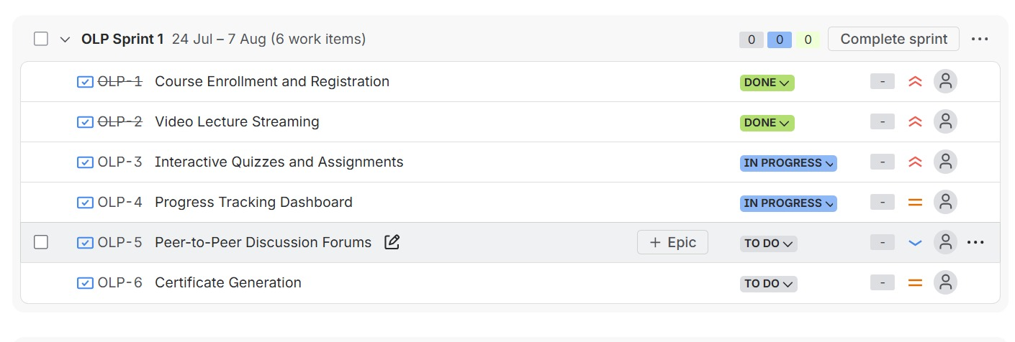/Should/Could/Won't) and the Kano model (Basic/Performance/Excitement/Indifferent) within Jira, and the backlog was organized accordingly for sprint planning.

